6.9.20

On June 15, the Marketing Unit will return management of Facebook pages back to individual parks and historic sites. Thank you for allowing us to coordinate social media messaging during this challenging time. We certainly saw the value of social media during a crisis, and we learned a great deal about your sites as well. We also hope this gave your staff more time to focus on other matters these past weeks.

Below are suggestions on how to move forward with managing your site’s Facebook page.

- Confirm that the appropriate people have administrator access. Do not remove any Marketing Unit staff from this list. (Go to Settings, then Page Roles.)

- Confirm that your user name and password are safely documented. The Marketing Unit does not keep passwords for the sites.

- Post photos and videos of what guests can see and do. Be mindful of photos that show groups of people (especially at beaches or other busy areas), ensuring everyone is at least 6 feet apart. When promoting cottage vacancies, remember that it’s more effective to show reasons guests should come to your park, rather than simply saying cottages are available.

- Create events that can be shared by your followers, and include capacity numbers if applicable.

- It’s okay to use the term “social distance,” but do not reference the pandemic or the coronavirus.

- Be sure to monitor the comments for vulgarity. Comments that contain offensive language may be hidden.

- On or before June 15th we will update the existing Auto-Reply with the one below. Feel free to edit and customize it if needed. Check your Facebook Inbox often, handling it the same as you would handle emails. Be sure to check direct messages and comments for questions or opportunities to engage with your followers.

Thank you for contacting ________ State Park. Please be patient as we will try to respond as quickly as possible. For more information about our park, please visit www.gastateparks.org/_________(state park). To make a reservation, please call 1-800-864-7275 or visit our website at gastateparks.org/reservations. To find out if our park is restricting day-use access, please visit gastateparks.org/alerts for live updates.

- Read http://explore.gastateparks.org/staff/resources/Marketing/Flyers-and-Social-Media-Tips.pdf for more tips. If you need assistance, or have questions please contact Kim Hatcher- Kim.Hatcher@dnr.ga.gov

Auto-reply editing instructions

- Go to your page and click inbox, it is in the top left corner of the screen.
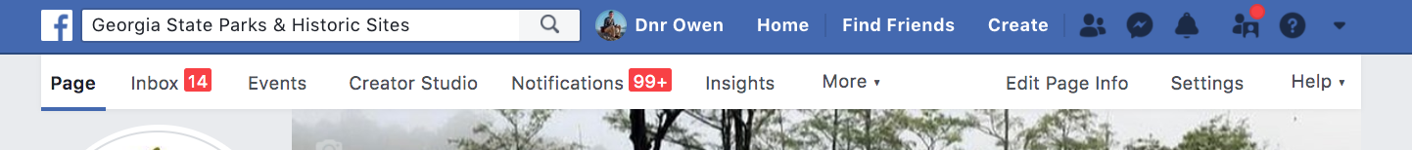

- On the left side of your screen, click “automated responses”

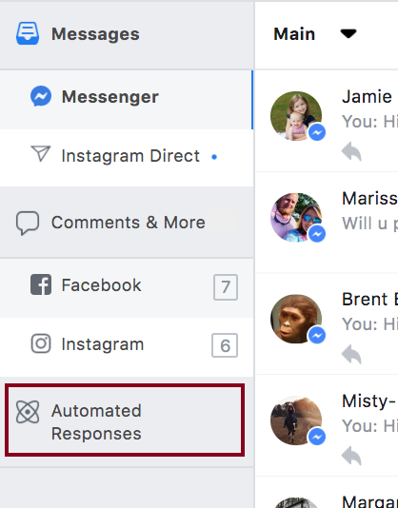

- Under instant reply, click edit.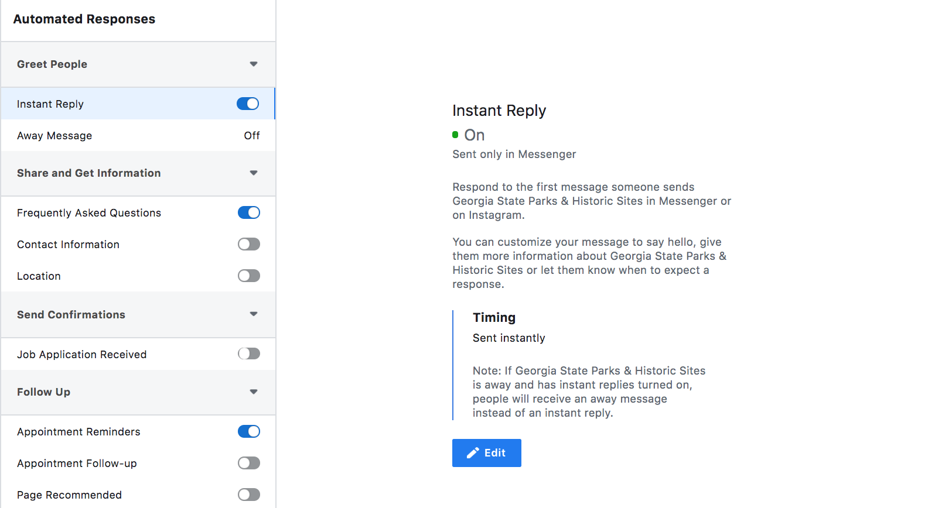

- Customize the message and click SAVE
